context:
I have made an implementation of a small office network with 3 branches.
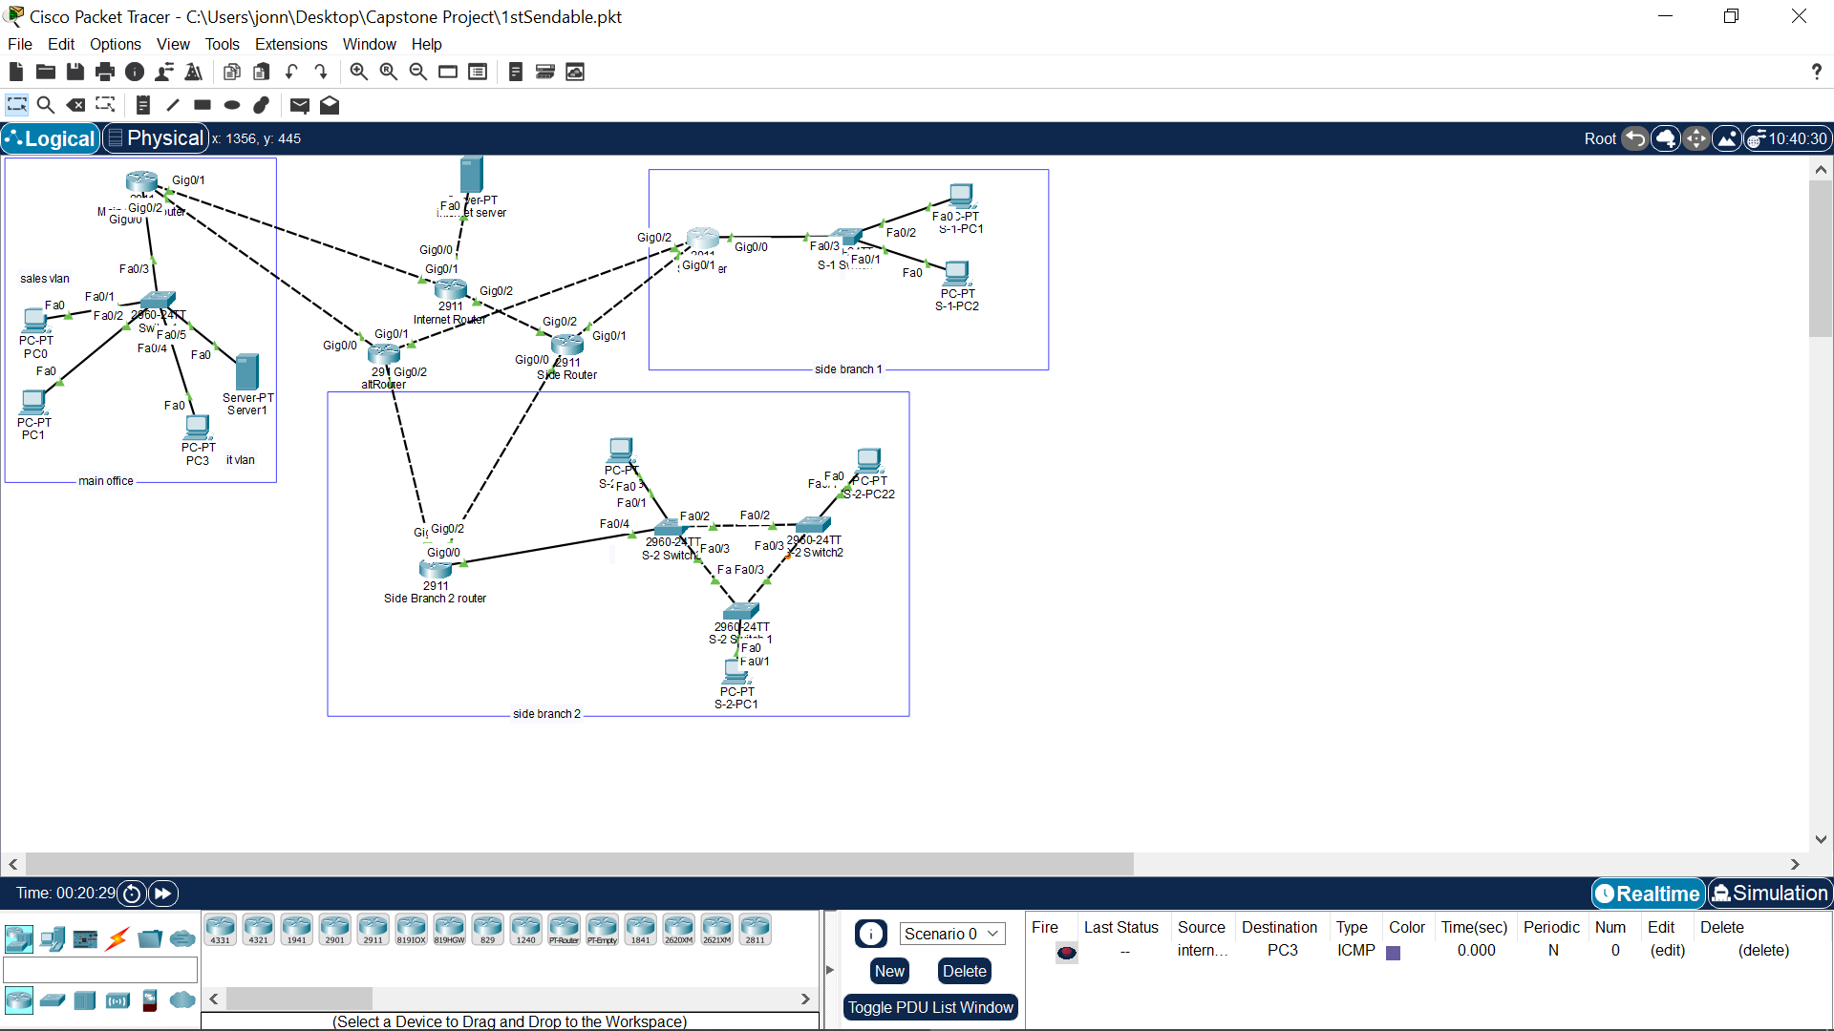 Fig. 0: Network topology

things to note:
- all devices can connect to internet (connect to internet server, via internet router)
- it takes a while for the devices to be configured (due to ospf config, wait before trying to send messages since it needs to find routes.)
- IPSEC VPN Tunneling has been implemented on the main office with the 1st side branch. However, connection times out or is unreachable. This could be due to my ospf config
- documentation doesn’t contain every configuration done to make the project. Use respective protocol commands to see how the protocols are used.
documentations
main router config:
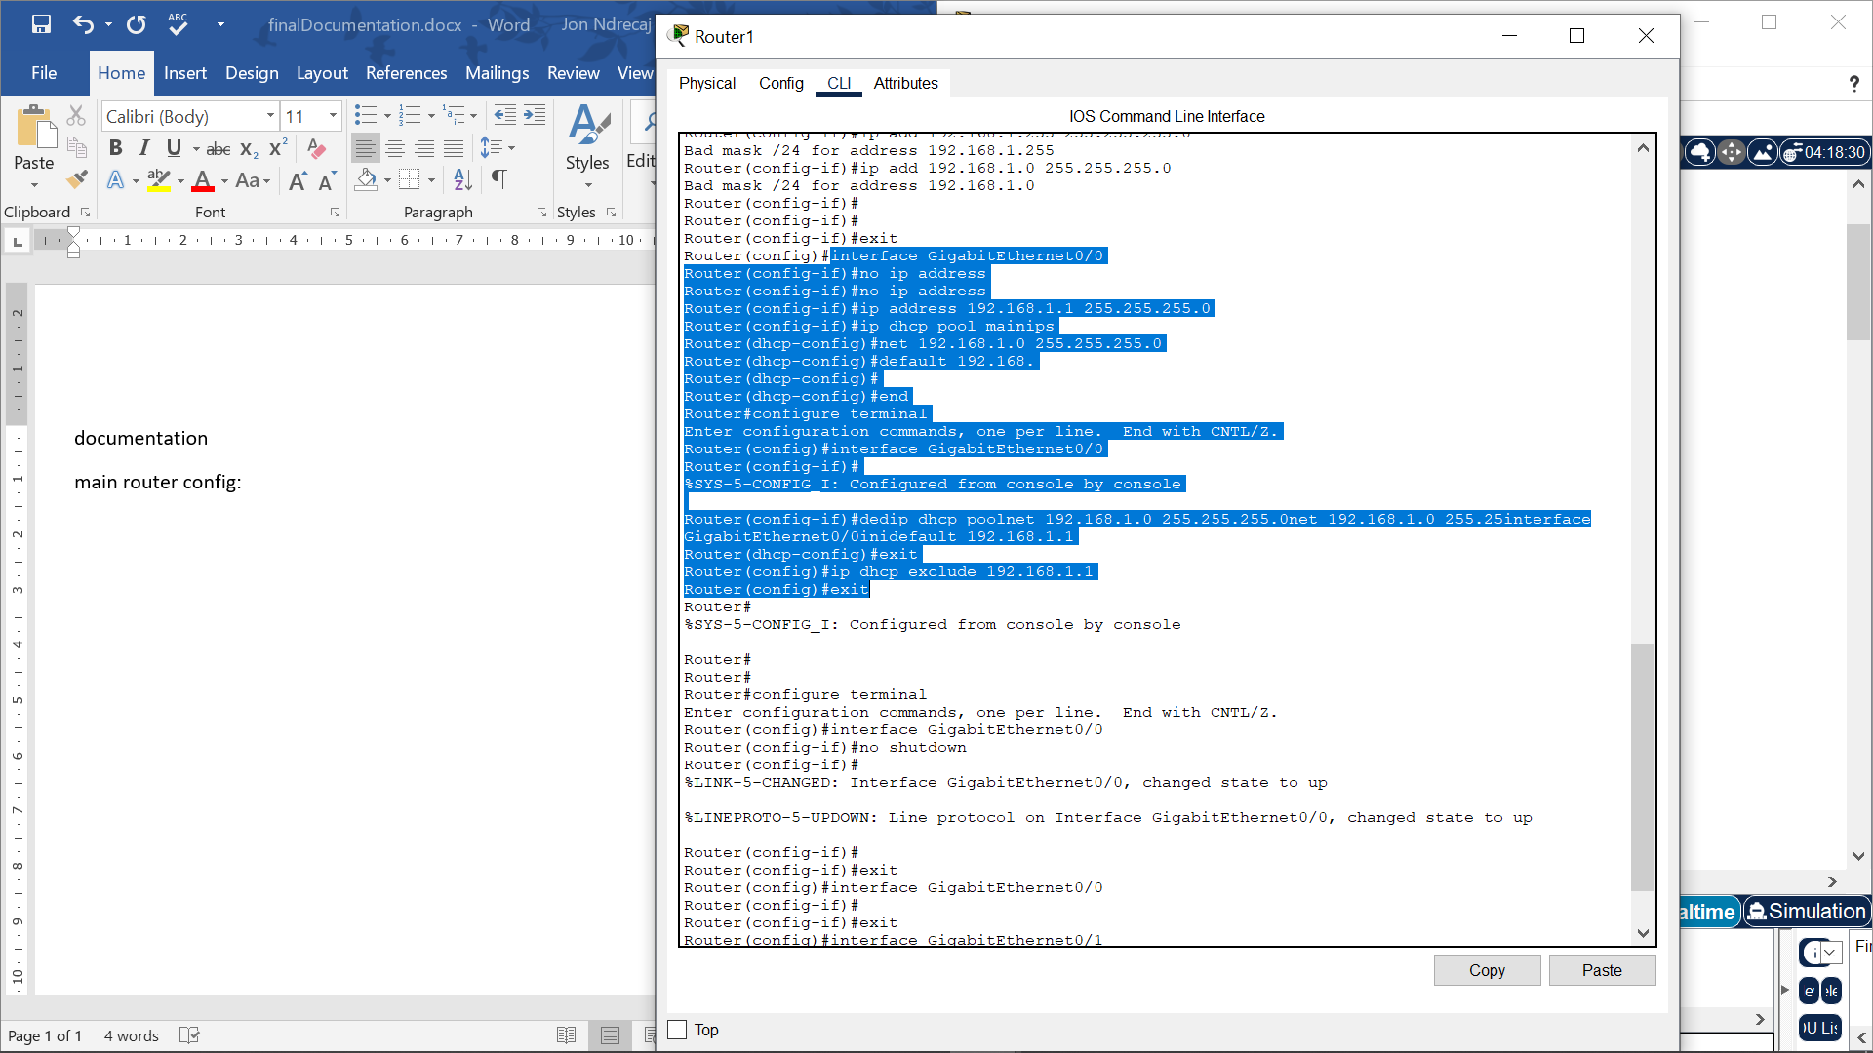
Fig.1: DHCP config (make sure to add no shut for interface)
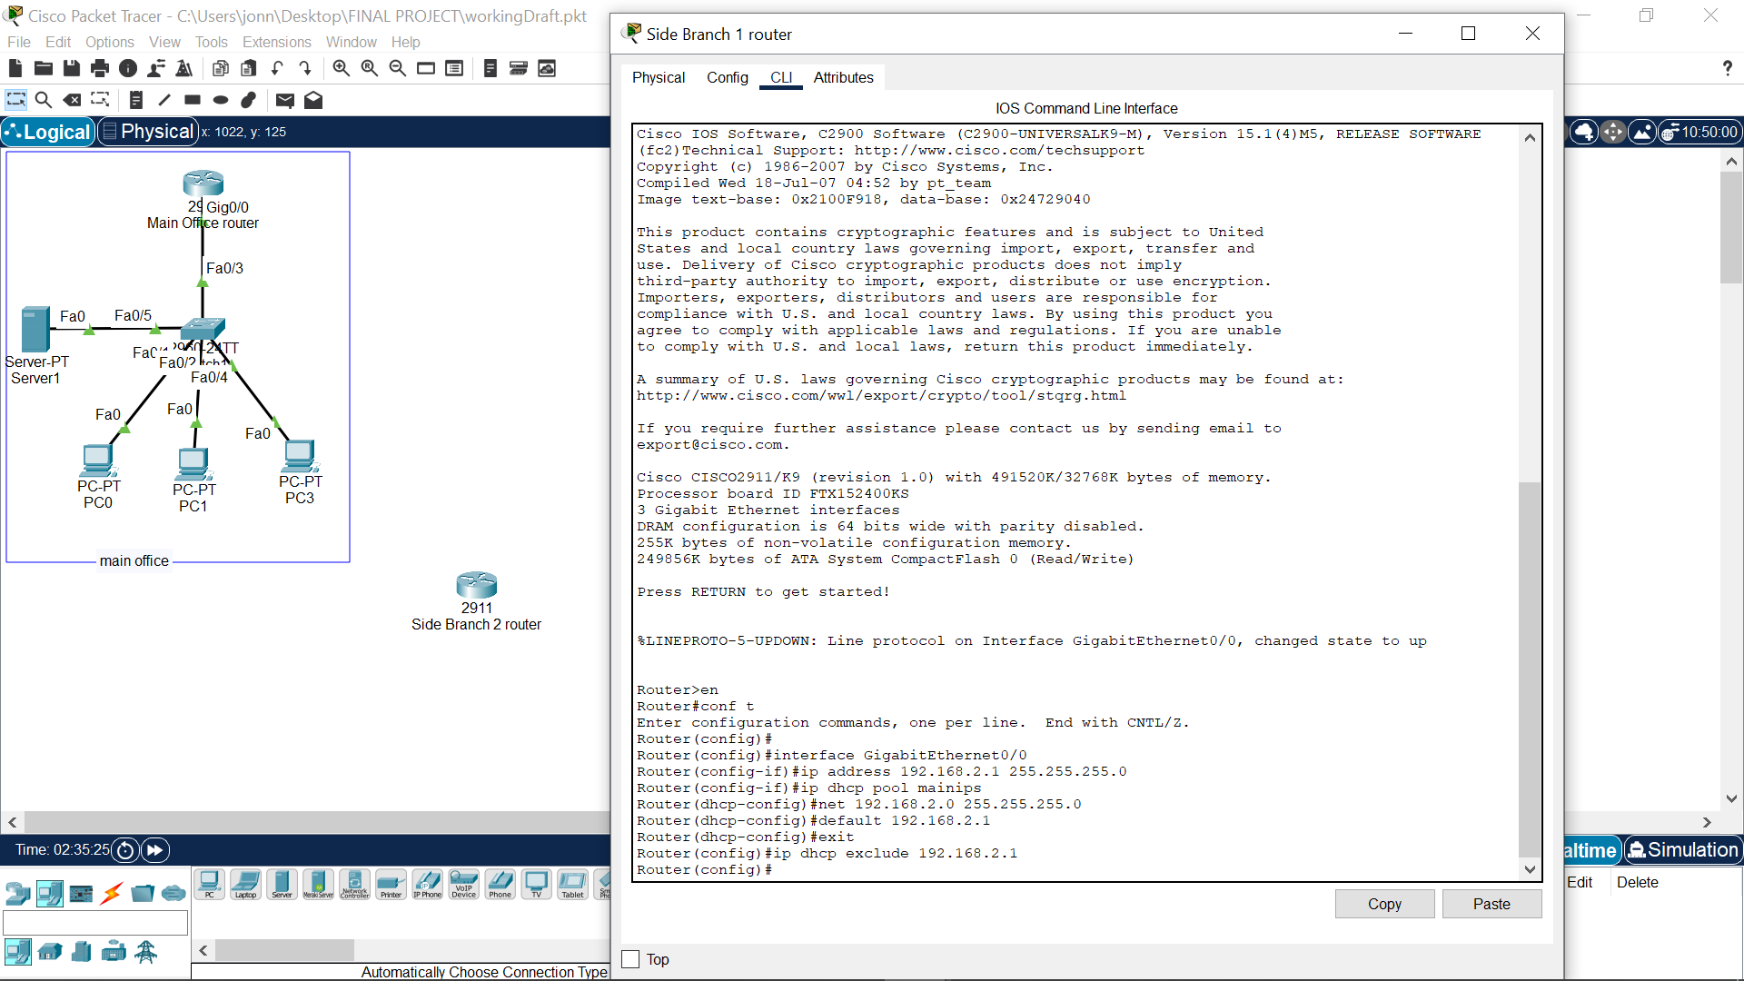 Fig.2: DHCP config for the 1st side branch

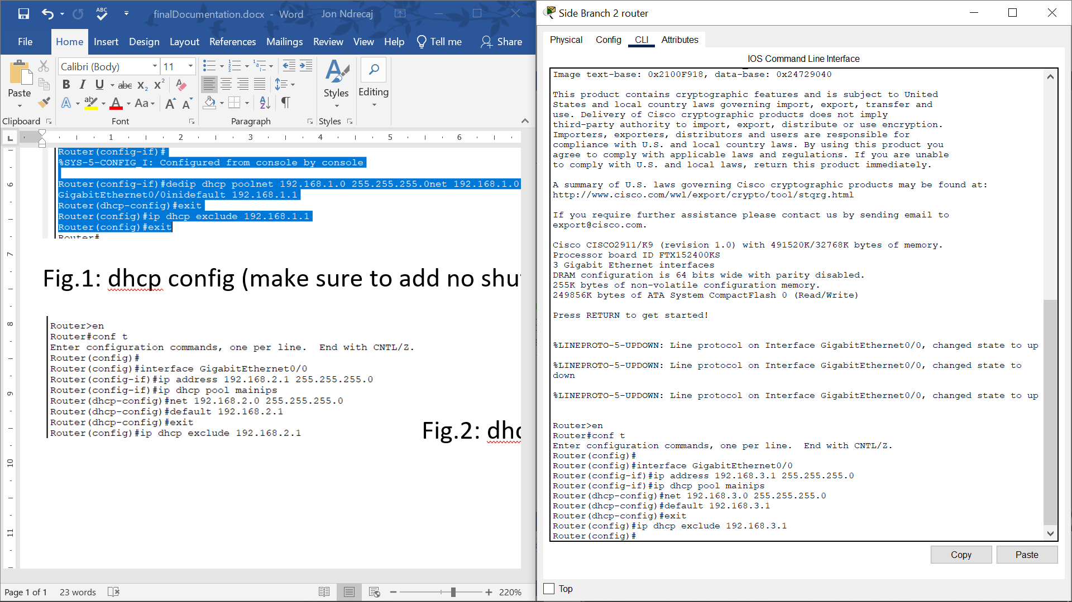 Fig.3: DHCP config for 2nd side branch

static route configuration to access internet simulation:
interface 0/1 for: (0/1 is path for internet router for each branchs)
router1,2,3: 10.10.10.1, 10.10.10.2, 10.10.10.3

static routes
successful route between main router – internet router
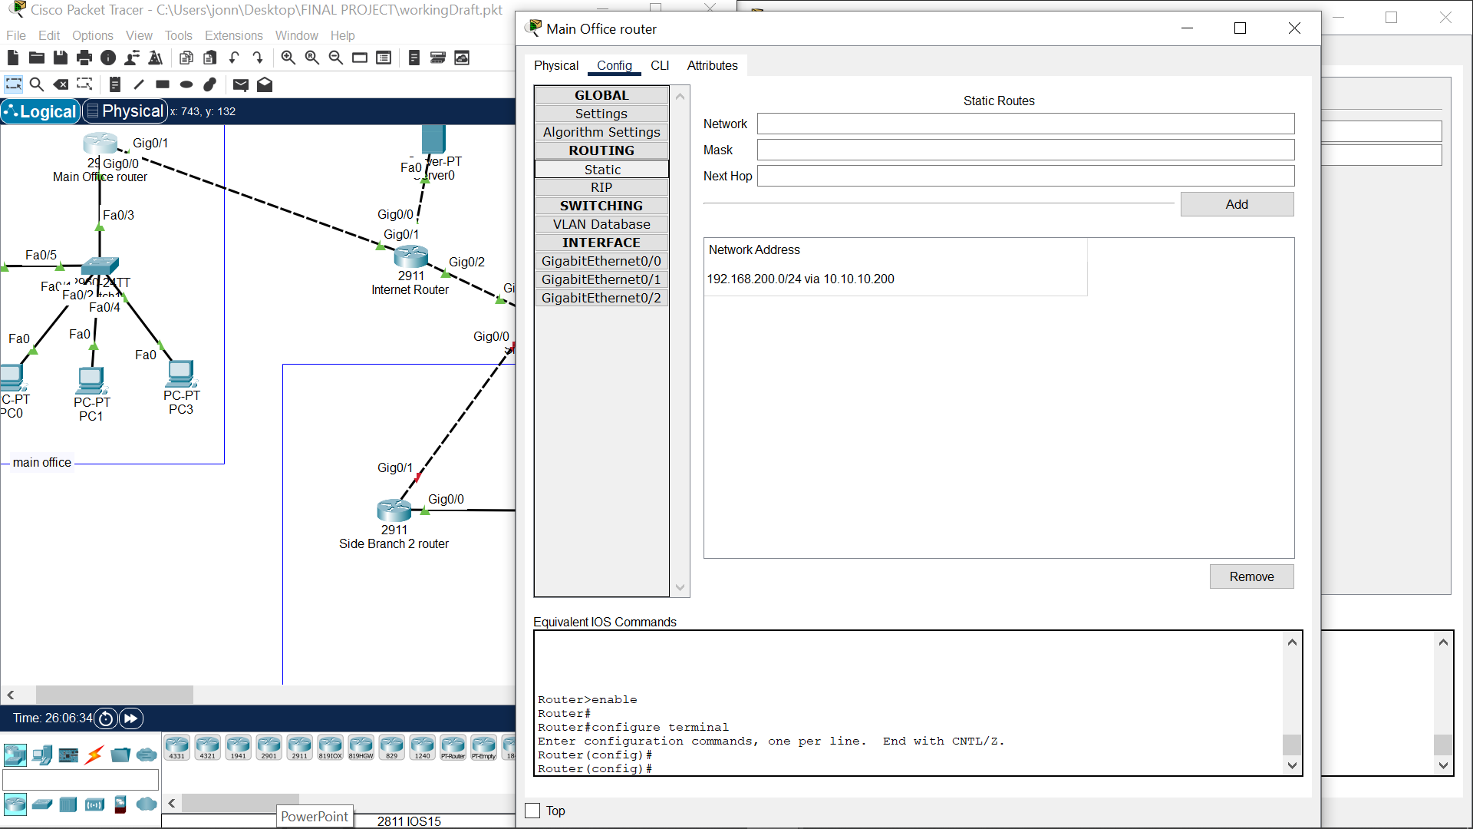
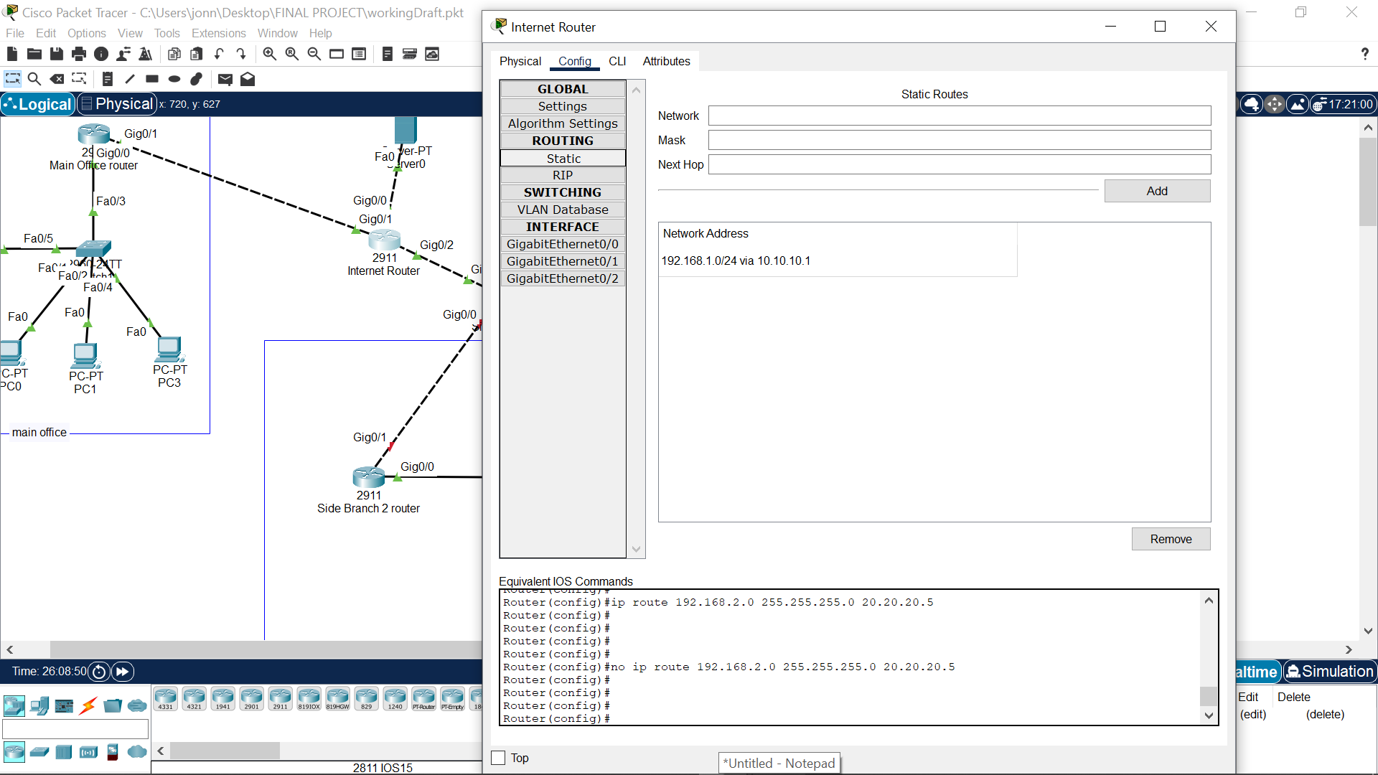 Fig.4: main branch to internet

FAILOVER REDUNDANCY:
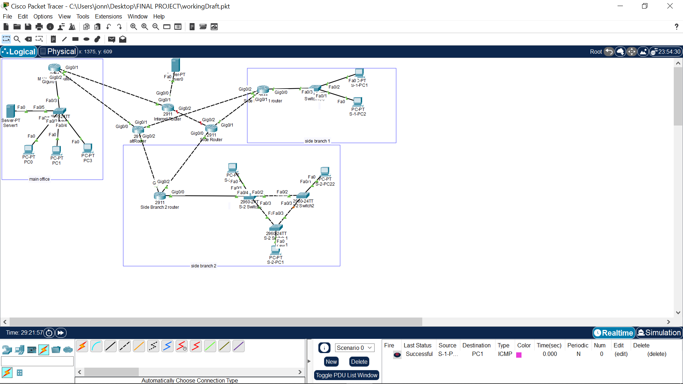
FIG. 5: Failover successful.

QoS commands used (for reference only):
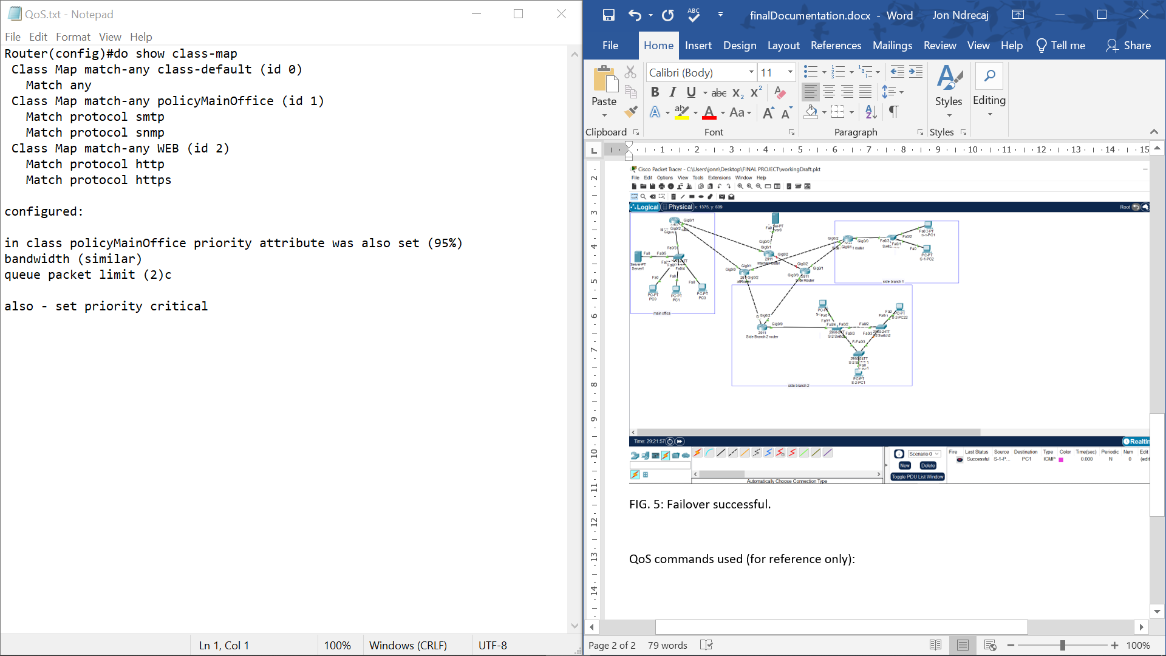Fig. 6: how QoS was configured

VPN commands for 1 router:
need to have securityk9 license enabled (check how to do that) as a prequisite:

Router(config)#crypto isakmp po
Router(config)#crypto isakmp policy ?
<1-10000> Priority of protection suite
Router(config)#crypto isakmp policy 30
Router(config-isakmp)#?
authentication Set authentication method for protection suite
encryption Set encryption algorithm for protection suite
exit Exit from ISAKMP protection suite configuration mode
group Set the Diffie-Hellman group
hash Set hash algorithm for protection suite
lifetime Set lifetime for ISAKMP security association
no Negate a command or set its defaults
Router(config-isakmp)#en
Router(config-isakmp)#encryption
% Incomplete command.
Router(config-isakmp)#
Router(config-isakmp)#encryption ?
3des Three key triple DES
aes AES - Advanced Encryption Standard
des DES - Data Encryption Standard (56 bit keys).
Router(config-isakmp)#encryption A
Router(config-isakmp)#encryption Aes
Router(config-isakmp)#encryption Aes 256
Router(config-isakmp)#encryption Aes ?
128 128 bit keys.
192 192 bit keys.
256 256 bit keys.
<cr>
Router(config-isakmp)#encryption Aes 256
Router(config-isakmp)#authentication pre-share
Router(config-isakmp)#life ?
<60-86400> lifetime in seconds
Router(config-isakmp)#life 3600
Router(config-isakmp)#gro
Router(config-isakmp)#Gro
Router(config-isakmp)#gr?
group
Router(config-isakmp)#Gr
Router(config-isakmp)#Group ?
1 Diffie-Hellman group 1
2 Diffie-Hellman group 2
5 Diffie-Hellman group 5
Router(config-isakmp)#Gr?
group
Router(config-isakmp)#gr
Router(config-isakmp)#group 5
Router(config-isakmp)#exit
Router(config)#crypto isakmp key example123 add
Router(config)#crypto isakmp key example123 address 50.
Router(config)#crypto isakmp key example123 address 50.50.50.1
Router(config)#crypt
Router(config)#crypto ips
Router(config)#crypto ipsec trans
Router(config)#crypto ipsec transform-set transformset1
% Incomplete command.
Router(config)#crypto ipsec transform-set transformset1
Router(config)#crypto ipsec transform-set transformset1 ?
ah-md5-hmac AH-HMAC-MD5 transform
ah-sha-hmac AH-HMAC-SHA transform
esp-3des ESP transform using 3DES(EDE) cipher (168 bits)
esp-aes ESP transform using AES cipher
esp-des ESP transform using DES cipher (56 bits)
esp-md5-hmac ESP transform using HMAC-MD5 auth
esp-sha-hmac ESP transform using HMAC-SHA auth
Router(config)#crypto ipsec transform-set transformset1 esp?
esp-3des esp-aes esp-des esp-md5-hmac esp-sha-hmac
Router(config)#crypto ipsec transform-set transformset1 esp-
Router(config)#crypto ipsec transform-set transformset1 esp-a
Router(config)#crypto ipsec transform-set transformset1 esp-aes esp-?
esp-md5-hmac esp-sha-hmac
Router(config)#crypto ipsec transform-set transformset1 esp-aes esp-sh
Router(config)#crypto ipsec transform-set transformset1 esp-aes esp-sha-hmac
Router(config)#access-
Router(config)#access-list 120 permit ip ?
A.B.C.D Source address
any Any source host
host A single source host
Router(config)#access-list 120 permit ip 192.168.1.0 0.0.0.255 50.50.50.1 255.255.255.0
Router(config)#crypto map vpn_feature 30 ip
Router(config)#crypto map vpn_feature 30 ipsec-isakmp
% NOTE: This new crypto map will remain disabled until a peer
and a valid access list have been configured.
Router(config-crypto-map)#set peer 50.50.50.1
Router(config-crypto-map)#set transf
Router(config-crypto-map)#set transform-set?
transform-set
Router(config-crypto-map)#set transform-set tran s
Router(config-crypto-map)#set transform-set trans
Router(config-crypto-map)#set transform-set transformset1
Router(config-crypto-map)#set transform-set transformset1
Router(config-crypto-map)#match address 120

